HUU HUNG PHAM

102643407@student.swin.edu.au

Class Thursday – 16.30

Tutor: Matthew Mulvaney

Assignment 1B

Cloud computing architechture

Table of Contents

Link to photo album: 1

Database record, screenshots show that I have been able to work with cloud database. 1

Screenshots show that I have been able to ping web server from test instance 2

Progress screenshot: 4

VPC config: 4

Config vpc with 4 subnets: 4

Correct Public and Private Routing tables with correct subnet associations 5

Security groups properly configured and attached. 5

TestInstanceSG 5

WebServerSG 6

DBServerSG 6

Create two EC2 instances, a test instance and a bastion/web server instance 7

Web server instance 7

Test instance 7

Elastic IP address added to web server instance 8

RDS database instance configuration: 9

Network ACL properly configured and attached 9

Inbound rules 9

Outbound rules 10

Photo stogare in S3 bucket is publicly accessible 10

Bucket Policy: 11

Photo URL in S3 bucket stored in RDS database meta-data 11

Photo album website works successfully: 12

# Link to photo album:

<http://ec2-18-235-17-10.compute-1.amazonaws.com/cos80001/photoalbum/album.php>

# Database record, screenshots show that I have been able to work with cloud database.

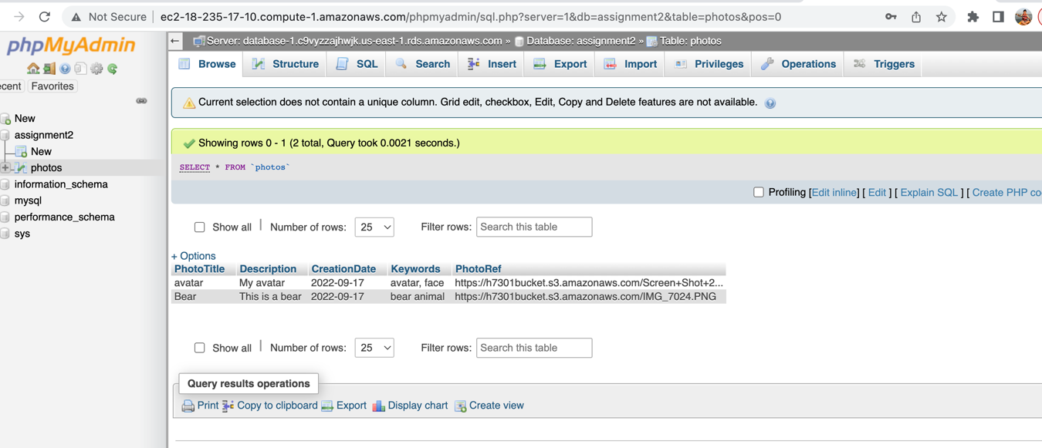

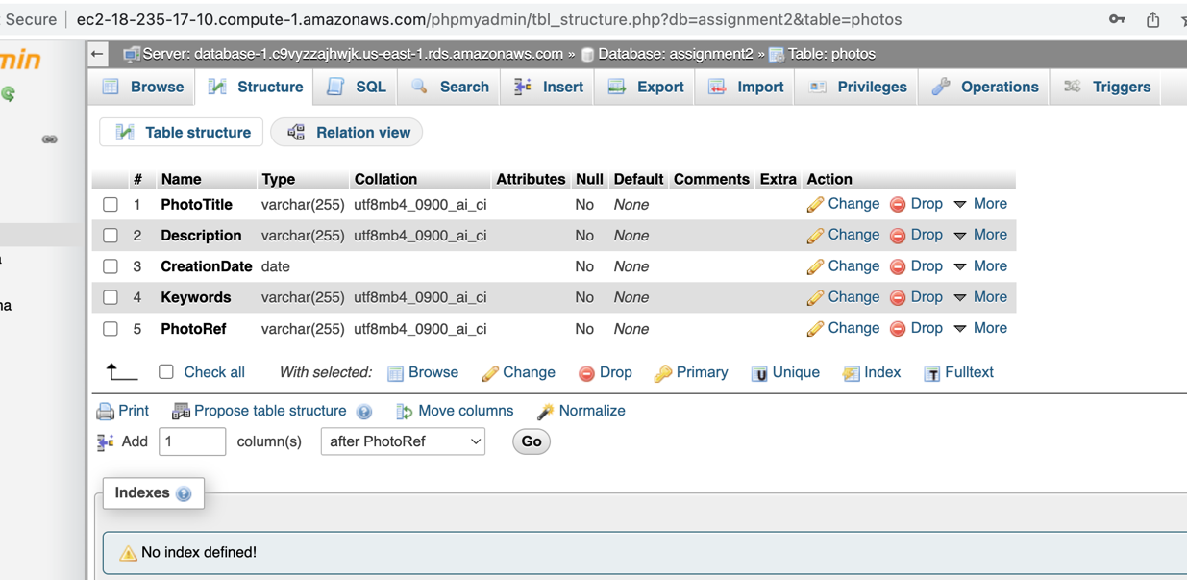

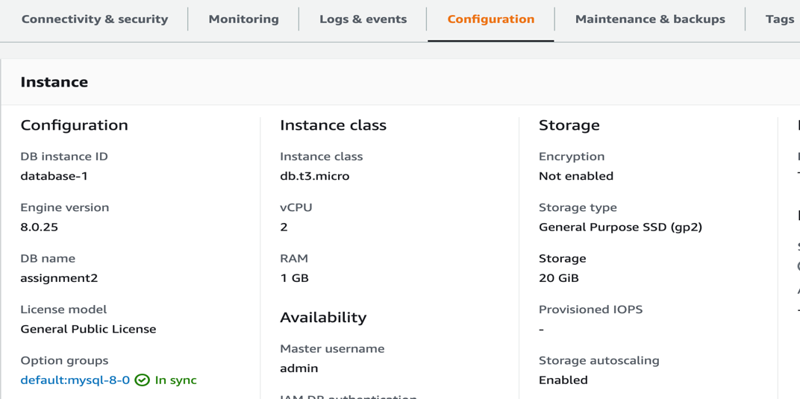

# Screenshots show that I have been able to ping web server from test instance

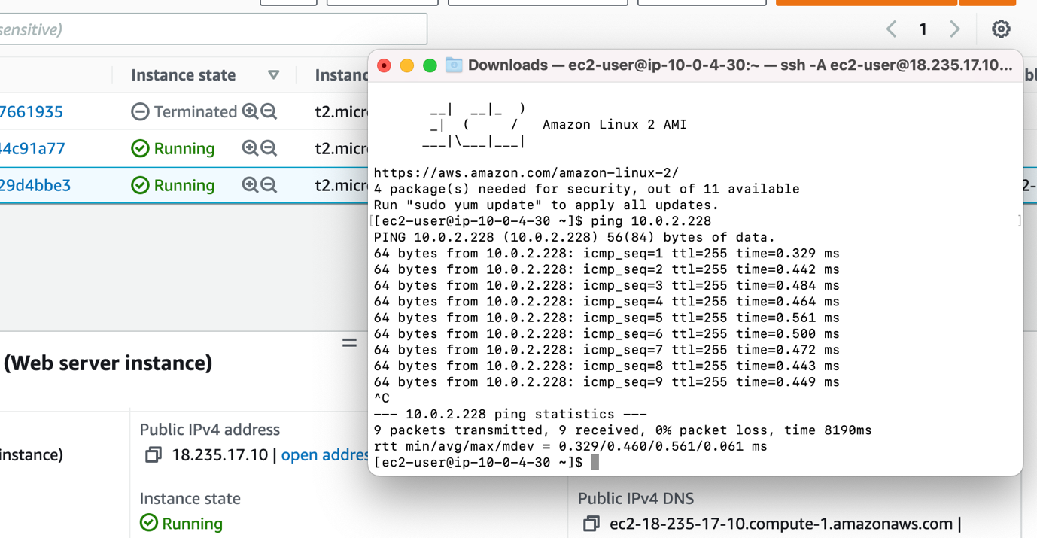

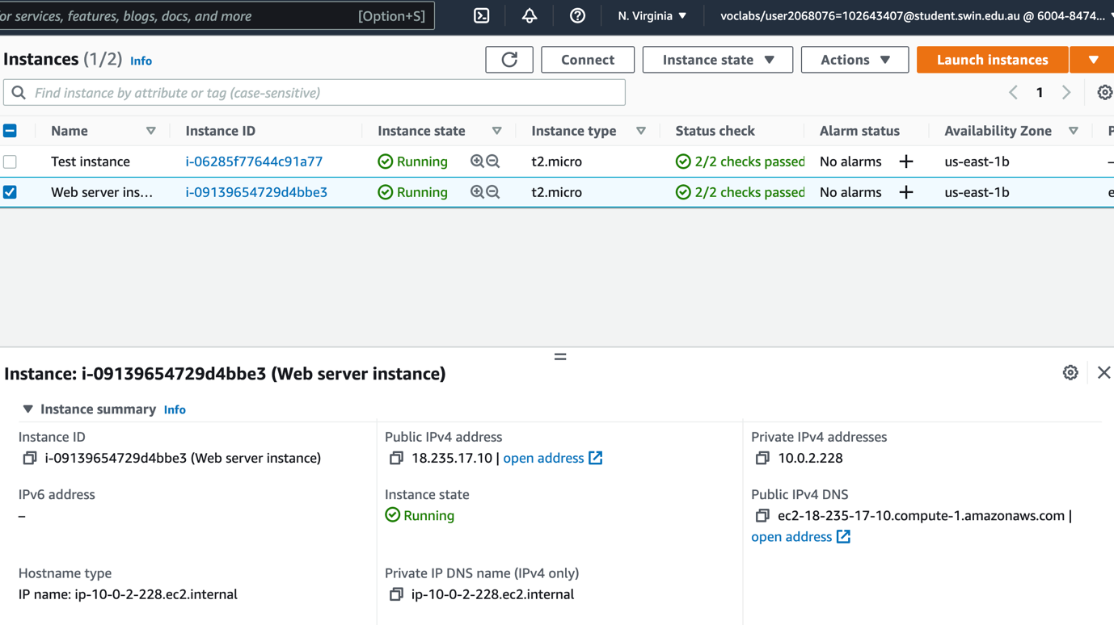

# Progress screenshot:

## VPC config:

### Config vpc with 4 subnets:

Have to check the infrastructure deployment carefully when deploy 4 subnets for the VPC

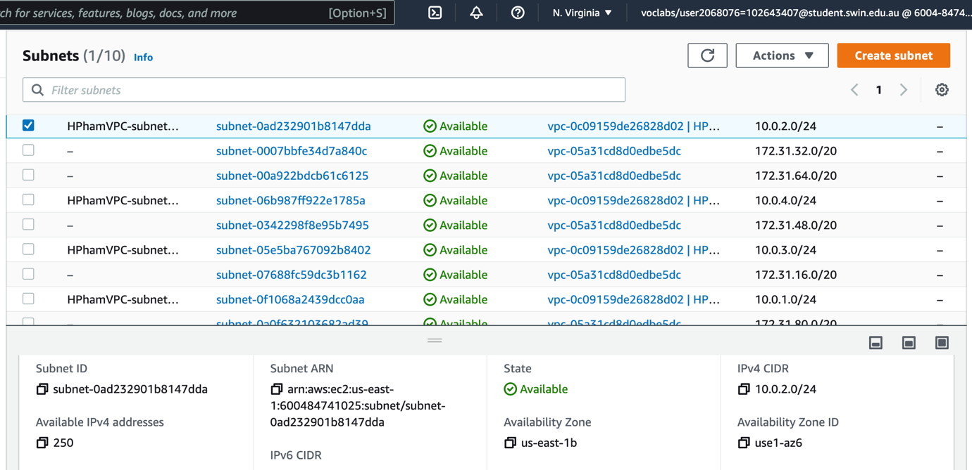

Check again the subnet IPv4 carefully

### Correct Public and Private Routing tables with correct subnet associations

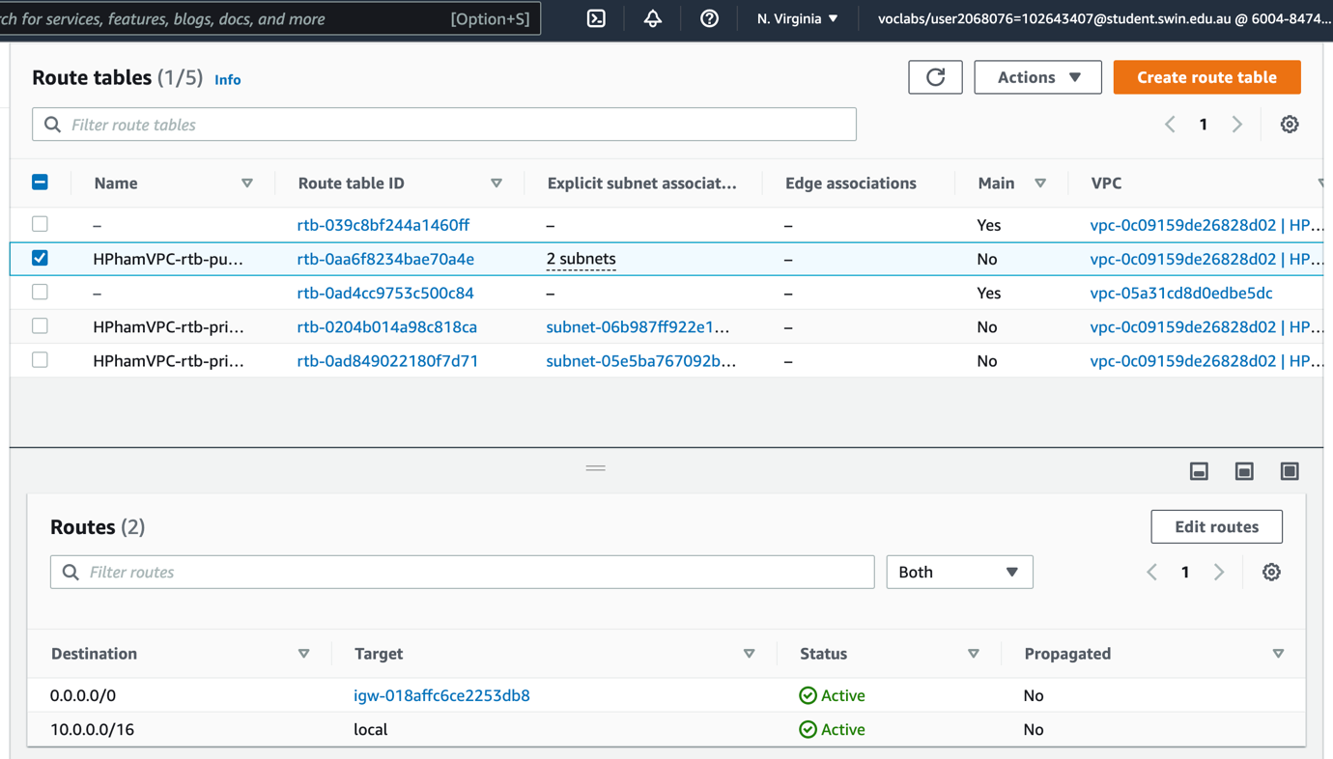

Check the correct subnet associations

## Security groups properly configured and attached.

### TestInstanceSG

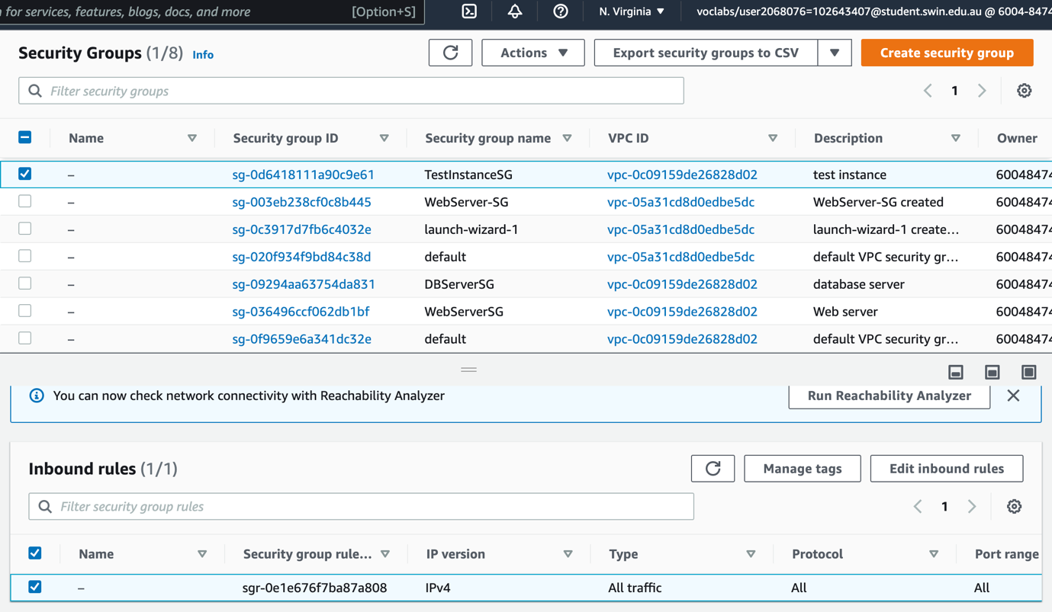

Creating test instance security group

### WebServerSG

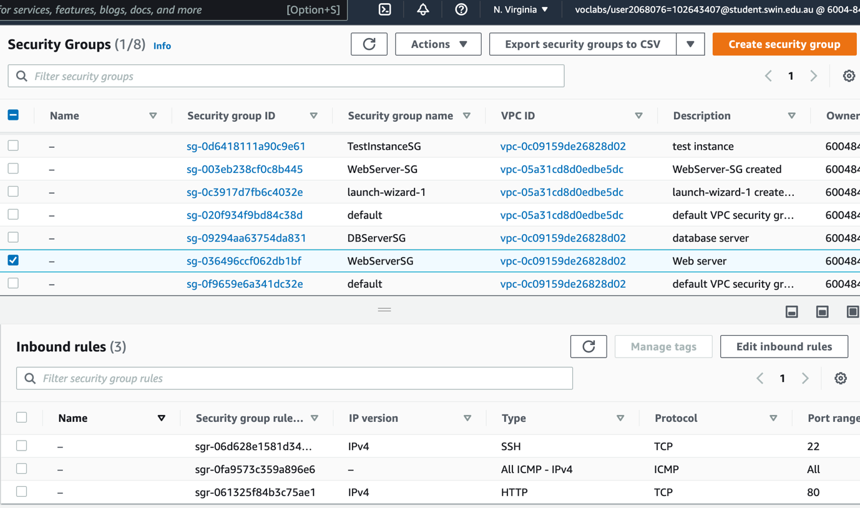

Creating web server security group

### DBServerSG

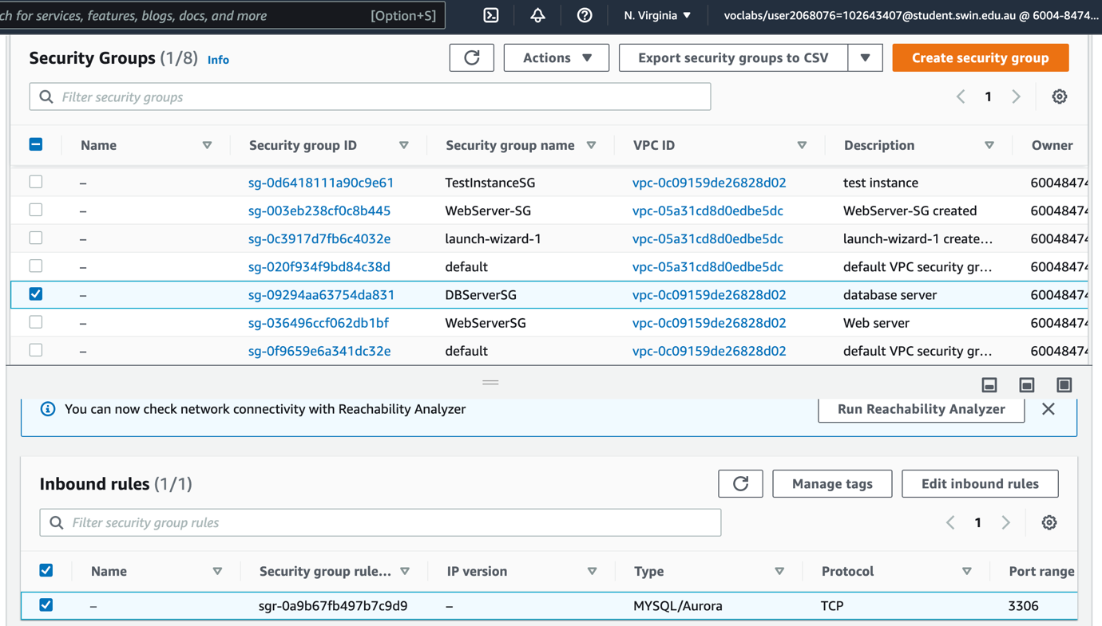

Creating the database server security group

## Create two EC2 instances, a test instance and a bastion/web server instance

### Web server instance

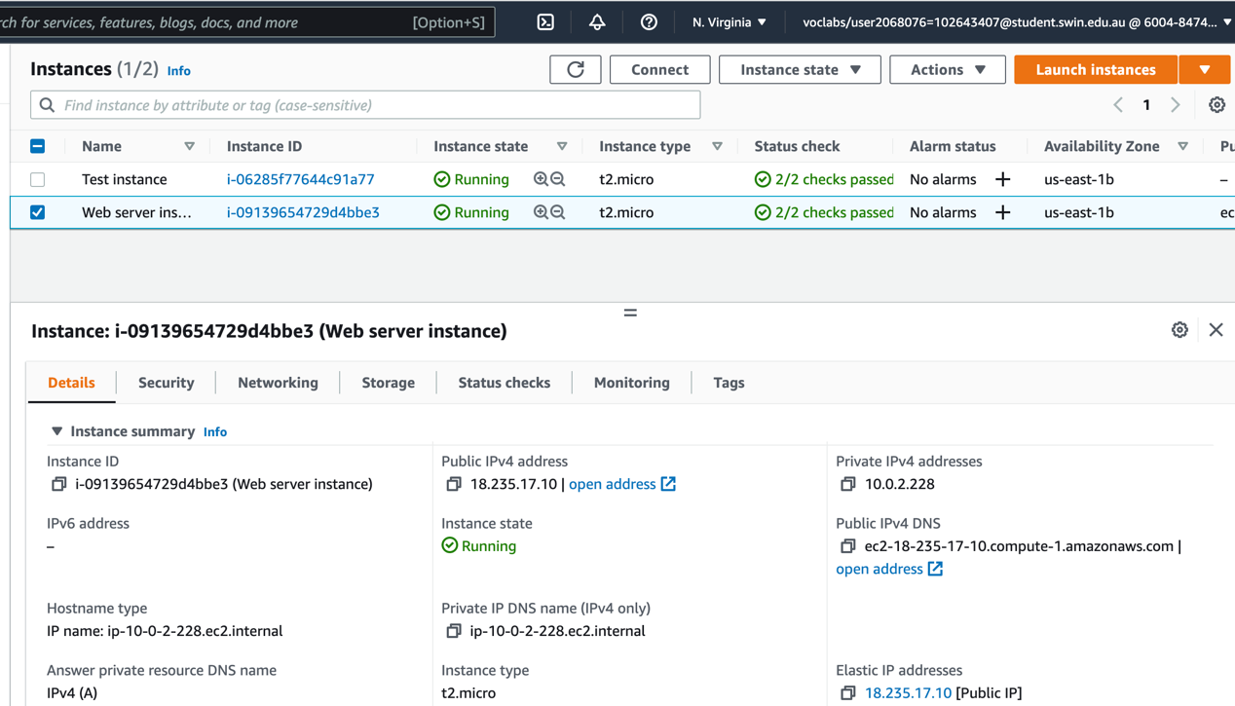

Note that web server instance must be in the correct subnet us-east 1b

### Test instance

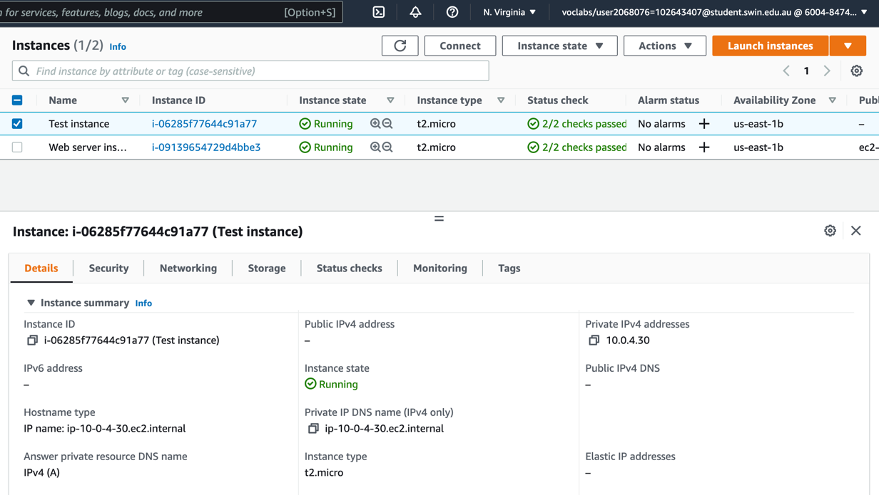

Note that test instance must be in the correct subnet us-east 1b

## Elastic IP address added to web server instance

Add a new elastic ip to web instance

## RDS database instance configuration:

Configuring the RDS instance

## Network ACL properly configured and attached

Inbound rules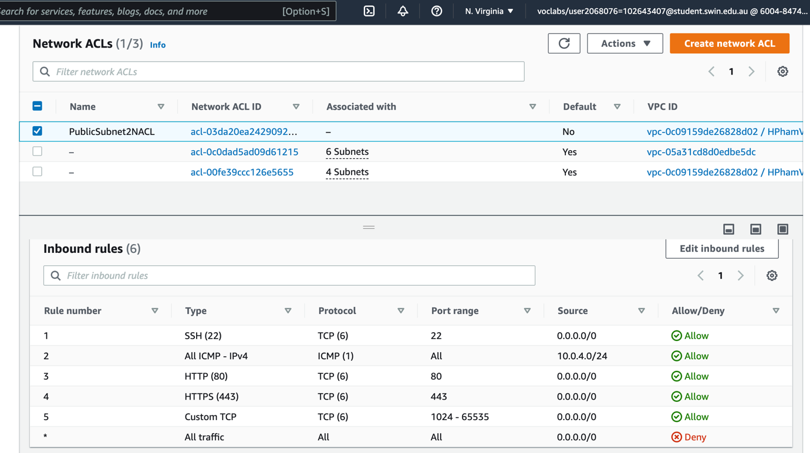

Note: Port range using Nat gateway range

### Outbound rules

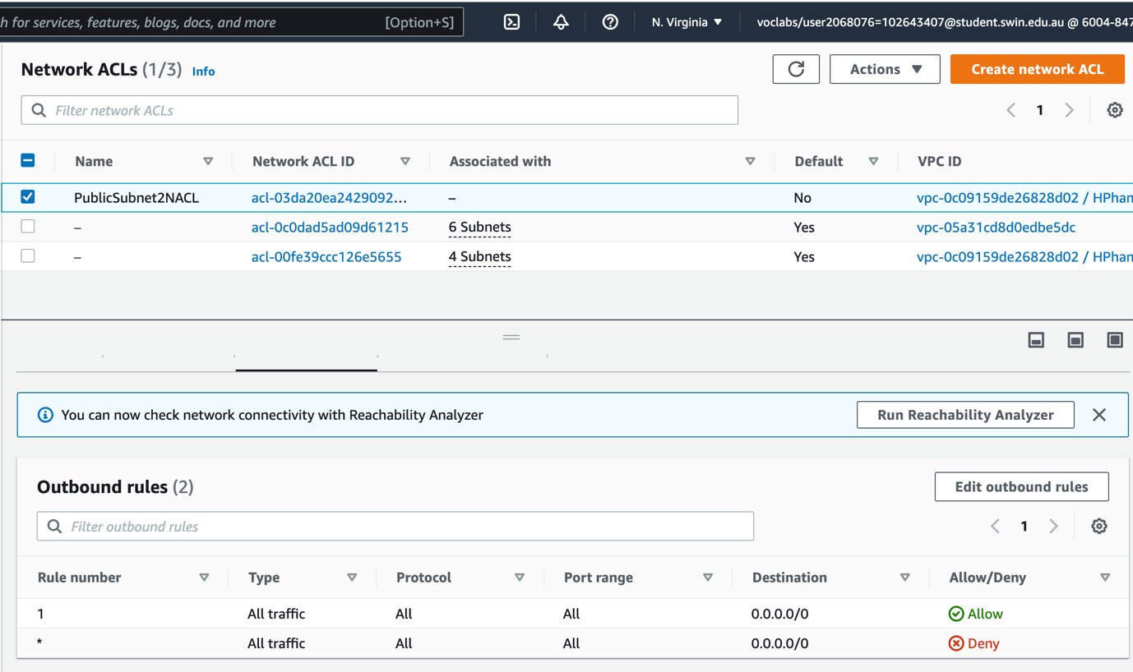

Note: Outbound rules not really specified in the assignment request. Allow all traffic

## Photo stoRaGe in S3 bucket is publicly accessible

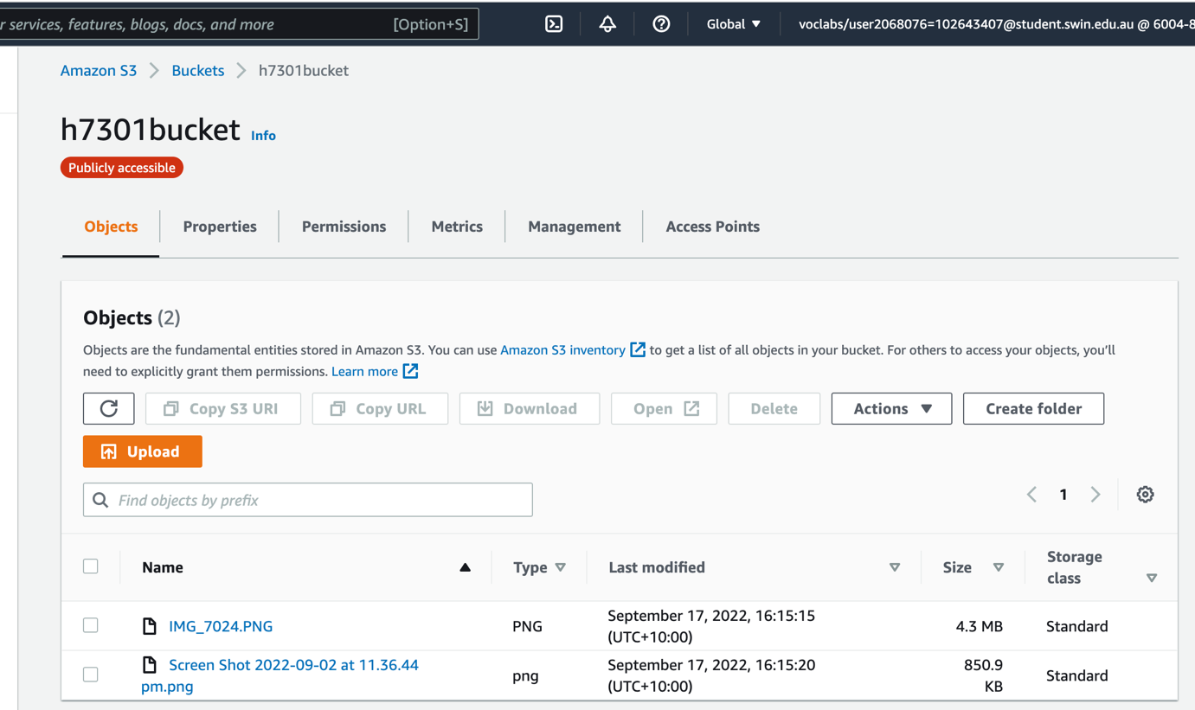

Added the photo manually and check if the photo is access publicly

### Bucket Policy:

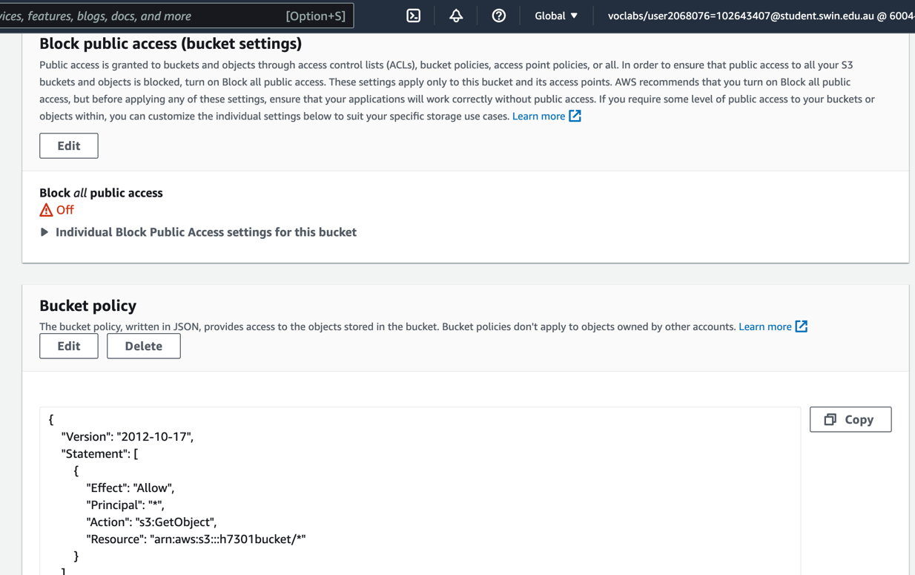

Configure the policy of bucket to make it public

### Photo URL in S3 bucket stored in RDS database meta-data

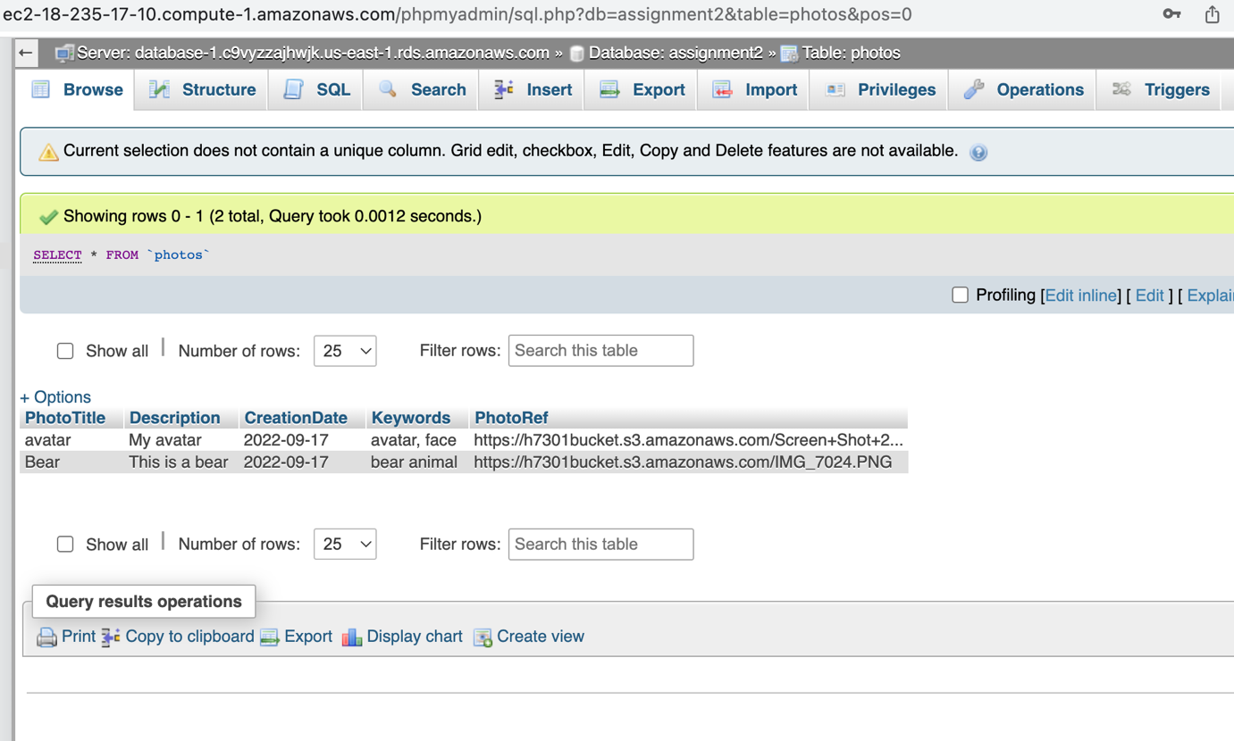

Add the photo link of S3 bucket to meta data

# Photo album website works successfully:

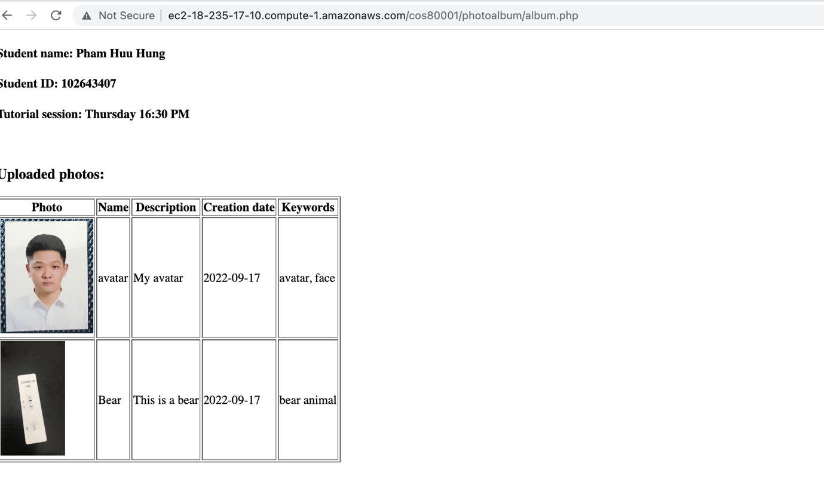

The website works well